SMART HEALTHCARE ASSISTANT

Ashbi Biju  Department of CSE  Apex Institute of Technology  Chandigarh University, Punjab, India ashbibiju5@gmail.com | Gnana Ravikumar Sivalinga  Department of CSE  Apex Institute of Technology  Chandigarh University, Punjab, India  kumarsivalinga66@gmail.com | Snigdha N.S  Department of CSE  Apex Institute of Technology  Chandigarh University, Punjab, India snigdhasumesh16@gmail.com

Abstract— This paper discusses the developing intelligent health assistant with an aspect of using natural language processing and deep learning for classification of the medical conditions, in a position to provide primary advice in the medical line from the input given by the patient. Work was on the architecture that involved the use of LSTM neural networks with its embedding layers to enable its process of textual symptom and conditions descriptions. In this way, the assistant could predict and provide possible diagnoses. A dictionary of present medical advice about common ailments such as asthma, diabetes, and hypertension help it respond quickly to patient's inquiries. Moreover, understanding symptom descriptions better through label encoding, techniques used in tokenizing and text pre-processing enhance model accuracy and applicability. The assistant also supports scheduling an appointment and storing patient records besides medical advice. The system uses various tools such as count plots, histograms, and heatmaps to describe main healthcare trends. With these, the demographics of patients, distributions of various conditions, workloads of doctors, and appointment schedules can be analysed. Predictive modelling and data visualization would give health care providers actionable insights for supporting clinical decision-making and administrative efficiency. Combining diagnostic support with patient record management, the assistant could give a pragmatic solution towards streamlining healthcare workflows in the interest of enhanced patient care.
Keywords— Natural Language Processing, Medical Condition Classification, LSTM Neural Network, Patient Records Management, Automated Medical Advice

INTRODUCTION
In the near past, AI and ML integration in healthcare has revealed much promise in transforming patient management, diagnostics, and delivery of healthcare. With NLP, machines can now process human language and interpret it accordingly. This is very advantageous in the healthcare domain as patient records and symptom descriptions are usually stored as unstructured text. As the demand for accessible healthcare continues to rise, an automated assistant in healthcare can be interpreted in terms of understanding the symptoms of a patient, management of the record, and provision of preliminary medical advice-advantageous to both the patient and the provider. This research focuses on developing an AI-based healthcare assistant that makes use of NLP and deep learning for medical condition classification and general guidance provision while handling patient data and assisting in routine healthcare administrative tasks[1].

In this paper, the central system has been designed on a Long Short-Term Memory neural network. In this proposed system, the base makes use of a deep learning model based on an LSTM neural network. Therefore, LSTM models are getting more and more popular in NLP applications, especially if the data is sequential. Examples are patient symptoms and medical conditions. We train this model on a dataset of medical conditions that enables it to predict probable diagnoses based on user descriptions of symptoms. This can be achieved by pre-processing the dataset with a few NLP techniques, such as tokenization, stop-word removal, and label encoding. This converts raw text data into a friendlier form to be fed to the model for the enhancement of the model's accuracy in diagnosing from unstructured free-text inputs[2].
In addition to this diagnostic aid, the health assistant is designed to provide a way to manage patients, which involves scheduling, storage, and retrieval of patient records. Automated assistance with scheduling enables patients to schedule appointments with health care providers without paperwork, which also opens up health care services. The management of patient records is one of the core elements since it will allow the healthcare providers to access and update important patient information, track medical history, and monitor treatment progress over time. The system centralizes patient records to enhance the efficiency and continuity of care. Visualization tools are integrated into the assistant to analyse healthcare data trends, enabling providers to make informed decisions. The assistant provides insight into patient demographics, the common patterns of various medical conditions encountered, appointment timing patterns, and provider workload through count plots, histograms, and heatmaps. Such analysis helps healthcare administrators optimize their schedules and resource use and draw demographic lessons applicable to specific medical conditions. Therefore, health institutions can alter the parameters of age and gender as well as most common appointment times to response for better service of the patients[3].
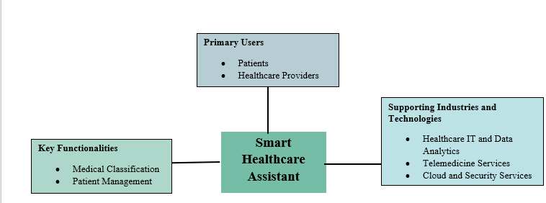
Figure 1 Block Diagram of Smart Healthcare Assistant
This assistant healthcare serves both sides of the medical sector: it meets patients and also in operation. It appreciates service in automated support diagnosis and provision of insights through analytics over administrative tasks. The resource is a good one toward pre-guidance as much as the symptom of the patient dictates, thus there could be an urge toward seeing the doctor when a situation occurs. In addition, it stores data and manages data. This goes a long way in giving continuity and consistency in treatment. In that case, the health care providers could deliver treatments much more precisely and effectively. As with the constant increasing demand of healthcare, there is ample scope to look for systems that may enhance the easy process as well as improve early symptoms of analysis thereby improving health delivery. This research contributes to the never-ending attempt at applying AI and ML in the use of healthcare, aiming towards making it more efficient and accessible, as well as patient-centred-good foundational grounds for intelligent systems to provide support in health environments within the future[3].

LITERATURE REVIEW

A. Existing System
Shan Anushka (2022) [1] Health-care assistant chatbot intended to adopt the COVID-19 scenario for healthcare professionals designed to provide diagnostic recommendation along with the level of symptom severity by using the power of machine learning. Discussion as above makes clear the utility of NLP in emergency health-care scenario.
K Antony Kumar and Jerlin Francy Rajan (2024) [2] have developed the Medibot: Personal Medical Assistant, which gives an auto-response to general health-related questions so that the practitioner will be freed from much of his work load. The system gives the response instantly. It resolves very routine health issues efficiently.
Binggui Zhou and Guanghua Yang (2024) [3] : They talked about NLP application for smart healthcare systems, different techniques of NLP, their applications in health-related tasks, focusing on NLP to improve the effectiveness and precision of healthcare delivery.
Arjen Hommersom (2013) [4]. of the project MoSHCA took on the development of mobile health assistants; they observed the technical and user-related issues faced by researchers for the designing of mobile systems that may assist in healthcare management by keeping in mind practical applicability for future work.
Arul Srinivasan and Neela Madheswari (2018) [5]. It proposed a smart healthcare system that integrates machine learning and the wonders of cloud computing where it can easily make appointments and manage health needs through a simple interface. It also uses voice recognition for fast service.
Mrs. Sharvari Patil and Ms. Jinal Darji (2021) [6] presented MEDIC: SMART HEALTHCARE AI ASSISTANT. It is an AI-based system that predicts diseases from the symptoms entered by a user. It will lessen the need for physical consultation and give preliminary diagnoses even remotely.
MAHMOUD NASR and MD. MILON ISLAM [7] (2021) discussed the integration of wearable devices, machine learning, and assistive technologies in smart healthcare. They claim the role of AI to monitor health conditions where real-time actual support is actually required for elderly and disabled patients.
Sanjida Nasreen Tumpa and Anika Binte Islam [8] (2017) designed in 2021 a pregnant woman assistant that proposes adapted health tips and diets as Smart Care. The system is supposed to aid the women at every stage of pregnancy with customized advice.
Dr. Meera Gandhi, Vishal Kumar Singh. 2019 [9] IntelliDoctor: AI assistant for medical tracking of user activities and providing diagnosis, recommendation for treatment, and monitoring health through an interactive interface. This enables the management of the overall health of the users.
Chalumuru Suresh [10] 2022. This proposed MediSmart, voice assistant, which can record patient history and prescriptions, employs NLP to process inputs from verbal communication, providing healthcare providers with recommendations in terms of decisions over management of patient data and also in the treatment procedure.

B. Proposed System
This would monitor the patient and ensure that management is done through a sophisticated intelligent healthcare assistant with advanced computational techniques capable of analyzing time-based data relating to patients in terms of changes in their symptoms, treatment responses, and health patterns over time using an LSTM (Long Short-Term Memory) model. This feature, therefore, shall enable dynamic understanding of the patient condition, permitting timely alerts and also matched recommendations for both the patients and the healthcare providers. The ability of LSTM to remember long-term dependencies is mostly effective while trying to predict potential health issues, thereby allowing a proactive approach to care for the patients, which enables healthcare providers to intervene early in patterns that might indicate complications.
Building on this patient management further, the system also utilizes natural language processing capabilities so that it can also accept unstructured patient data such as descriptions of symptoms, questions, and medical histories in structured forms that will properly help in analysis and categorization. These automated processes increase the accessibility of critical details of patients that cut down the time of triage, scheduling, and treatment decisions. It also reduces missed appointments through the automation of scheduling, and follow-ups, that is to say, the system ensures that treatment interventions are timely. This proposed system looks into how accurate records are maintained, how effective communication occurs, and how care is handled within a seamless process thus centering on the patient the core of efforts aimed at advancing healthcare delivery and outcome.

METHODOLOGY

A. Dataset
We prepared a health-oriented dataset of 2000 to train and test the developed healthcare assistant model during our study. We designed the dataset such that it contains all pertinent details commonly seen within clinical contexts, using columns for name, gender, age, doctor, appointment time, date of admission, and medical condition. This data structure captures basic patient demographics, medical conditions, and appointment details on which the creation of a realistic and relevant patient records is founded. These were chosen because they reflect many common interactions in healthcare, making this dataset a practical foundation with which to develop both predictive and administrative functionality.
Columns name, gender, and age are basic demographic details. Gender and age are important to observe the perception of the disease pattern and demographic pattern which enable the assistant to pick some trends, such as that which condition is more prominent in any age group or gender. Doctor is one of the healthcare providers for the patient enabling us to perceive how appointments are distributed among doctors, hence which doctor has the maximum number of appointments. These also include appointment time and the date of admission, which adds a temporal dimension, which helps the assistant in terms of scheduling capability as well as analysing peak times in terms of patients and all other trends in the service provision timing.
The column for medical condition, which is the diagnosis or symptoms complained of by patients. These are the main inputs while training the classification model in the assistant. To make this field useful for the NLP model, we ensured that it contained a variety of conditions that are commonly encountered in clinical practice, such as respiratory issues, chronic illnesses, and mental health concerns. This diversity in the field allows the model to learn from a wide range of medical scenarios, enhancing its accuracy in predicting conditions and providing advice. Overall, this dataset is made to mimic the real healthcare environment, thus being very useful for the development of a general healthcare assistant capable of performing both predictive analysis and patient management.

B. Implementation of NLP
This project would make it easier to interact with patients so that the health assistant would be able to interpret and respond accordingly in light of the queries asked. The following steps, based on the high-level states of the NLP implementation:

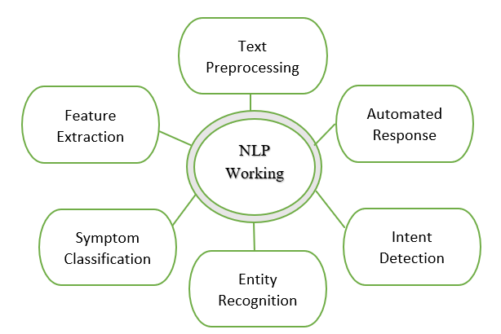
Figure 2 NLP Working

Text Pre-processing In the first place, pre-processing patient inputs transform data into a better shape or readable form. Standardization techniques such as lower-casing, removal of stop words, and lemmatization standardize text for analysis free from extraneous words that may interfere with outcome[4].
Such methods used for transformation include the term frequency-inverse document frequency and count vectorization, all of which are used to convert the text data. All these forms of clean texts transform into numerical vectors to take input from them and adapt them within ML models.
Classification of Symptoms: The system accepts the input of deciphered symptoms that the patient receives and interprets them into relevant medical conditions they actually suffer from. The picking up of such recognizable patterns and terms of health condition does make the assistant more compatible with the classification of symptoms and much more capable of steering the patients toward relevant insights[5].
Identification of Entity Simple entities like medical symptoms, medicine, or health-related words from the patient's query are fetched. This step helps the system fetch information that the system could possibly understand each case more vividly and eventually hold a more personalized answer.
This assistant identifies the main intent of a patient's entry, such as appointment scheduling, symptom check, or medication query. The system will respond accordingly since that matches the needs of a patient.
Automated response generation. Depending on the classification and detection of entities, the system will thereby generate relevant responses, from guidance in diagnosis to the exploration of symptoms or indication of what is required next. This would therefore result in an altogether smooth and effective consultation with patients.

C. Implementation of LSTM
In the implementation of the Long Short-Term Memory (LSTM) model within the smart healthcare assistant, the primary goal is to classify medical conditions and manage patient records efficiently[6].
Forget Gate Calculation: It calculates at the forget gate which it is supposed to allow movement forward from the former state of the cell and which it is supposed to flush. It is fundamentally indispensable in the health-care data because the data of patients sometime back do not always make sense. The forget gate formula is thus expressed as follows:
$f_{t}=σ\left(w_{f}⋅{[h}_{t^{-1}},x_{t}\right]+b_{f}$)

Where $w_{f}$​ and $b_{f}$ are weight matrix and bias for forget gate,
$h_{t}-1$ is the previous hidden state, and ​$x_{t}$​ is the current input. This mechanism enables the model to selectively "forget" obsolete or irrelevant patient information while retaining useful data. This is computed using a sigmoid activation function applied to a linear combination of the previous hidden state $h_{t}-1$ and current input $x_{t}$​.

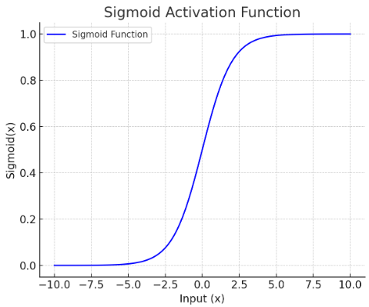

$$σ\left(x\right)= \frac{1}{1+ ⅇ^{-x}}$$

Input Gate Computation: The input gate decides what is to be stored into the cell state. This is useful when recognizing patterns of symptoms within patients, or perhaps patterns of medical history. That can be written as
$$i_{t}=σ(w_{i⋅[h_{t}-1,}x_{t}]+b_{i})$$

Where $w_{i}$ and $b_{i}$ are the weight matrix and bias for input gate. It can update its dynamic relevant patient information after receiving new inputs, symptoms, even diagnostical result[7].
Candidate Cell State Calculation:
The candidate cell state ${\tilde{C}}_{t}$ is a suggested update to the current cell state when new information is merely observed. It is presented as follows:
$${\tilde{C}}_{t}=\tan{h(w_{C}}⋅{[h}_{t}-1,x_{t}]+b_{c})$$

Updating Cell State: Cell State $C_{t}$ This combines information between the forget and input gates, and this allows the model to have a smooth flow of relevant information without interruptions.
$$C_{t}=f_{t}⋅C_{t-1}+i_{t}⋅{\tilde{C}}_{t}$$

This means that information related to the patient, such as diagnoses he or she has ever had, is maintained and added with new relevant information[8].
Output Gate Calculation: The output gate controls what to output as the hidden state from the cell state component, $h_{t}$ thus in turn, alters the prediction or classification that is to be made by the model.
$$O_{t}=σ(w_{0}⋅[h_{t-1},x_{t}]+b_{0})$$
Where $W_{0}$ and $b_{0}$ are the output gate weights and bias. This hidden state is what, finally impinges upon the ultimate medical classification or recommendation[9].
Final Hidden State Computation: The hidden state $h_{t}$ is the output of the combination of an output gate and cell.
$$h_{t}=O_{t}⋅\tan{h(c_{t}})$$

The other one is the loss function, in this case implemented in the code for optimization of the LSTM model because it is tailored specifically for multi-class classification tasks
Final Output Layer using SoftMax Activation: The final output layer uses SoftMax activation, which generates a probability distribution over each of the medical classifications, making it possible to be able to explain what the assistant is generating.

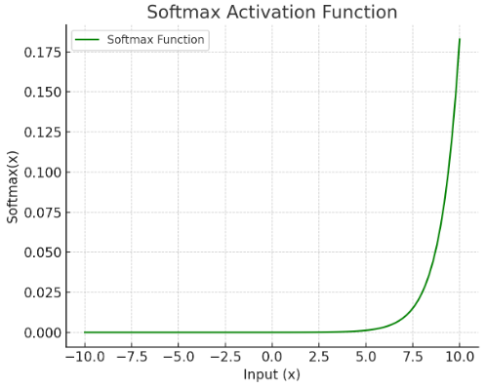

$$Softmax\left(x_{i}\right)= \frac{ⅇ^{x_{i}}}{∑j^{ⅇ^{x_{j}}}}$$

These outputs serve as inputs for further layers to produce prediction such as when to classify the status of a patient or when to offer further treatment alternatives.

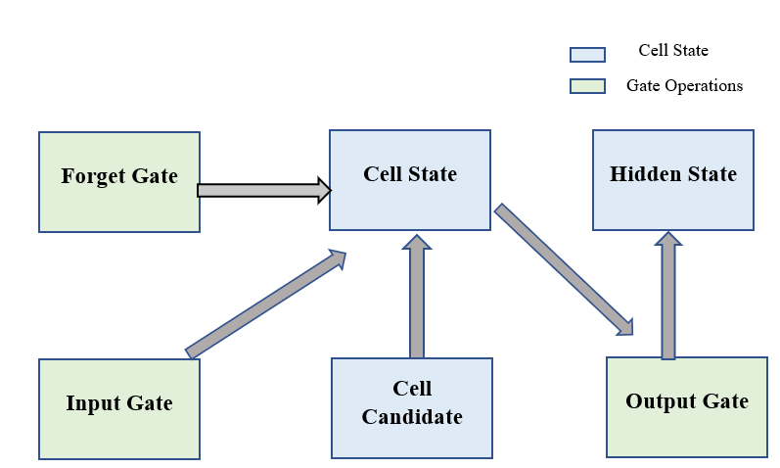
Figure 3 LSTM Network Workflow

Implementation in healthcare assistant LSTM allows a fine-grained approach on how to handle sequential healthcare data. Having any gate operation give the model a possibility for focusing selectively on important facts within the patient's historical and current data gives it an ability at higher accuracy for correct classifications or recommendations[10].

- RESULT AND DISCUSSION

The Results and Discussion section reveals how the LSTM-based health assistant predicts medical conditions by promising accuracy and reliability along with metrics such as accuracy, precision, recall, F1-score at high performing levels. ROC curve with AUC is confirmed by models showing some potential for diagnostic goodness, minor challenges arising as sometimes conditions overlapped and symptoms were occasionally classified as the same. The LSTM approach has all the capabilities of learning from sequential data and integrating NLP into its framework, thereby permitting it to process and interpret patient symptoms in an infinitely much more contextual way than those used in traditional systems, thus markedly increasing utility in clinical decision support. It can be utilized for triaging, remote monitoring of patients, and as a potential stepping stone for diagnostic recommendations-all highly valuable in both clinical and telemedicine settings. Future developments could focus on misclassification issues and introduce new capabilities to improve the specificity of the model or its usability.
- CONCLUSION

The Automated Healthcare Assistant for Medical Classification and Patient Management would illustrate that through automation, machine learning would be implemented in order to improve healthcare service delivery. Easy medical condition prediction with ease of management of patients would be such that scheduling of appointments and follow-ups would occur subsequently, ensuring maximum productivity by the health care professionals and minimum time spent by the health care professionals in paper work. Promising but more diversity in the data, refining the accuracy of the models, and then integrating in a system setting may enhance its broad application and, therefore usefulness, in everyday life.

REFERENCES
[1] B. Anjaria and J. Shah, “International Conference on Smart Data Intelligence Adversarial Attacks and Classifiers : A Review,” no. Icsmdi, pp. 1–7, 2021.
[2] M. Nasr, M. M. Islam, S. Shehata, F. Karray, and Y. Quintana, “Smart Healthcare in the Age of AI: Recent Advances, Challenges, and Future Prospects,” IEEE Access, vol. 9, pp. 145248–145270, 2021, doi: 10.1109/ACCESS.2021.3118960.
[3] A. Srinivasan and A. N. Madheswari, “The Role of Smart Personal Assistant for improving personal Healthcare,” Int. J. Adv. Eng. Manag. Sci., vol. 4, no. 11, pp. 769–772, 2018, doi: 10.22161/ijaems.4.11.5.
[4] S. Anushka and S. Thelijjagoda, “Healbot: NLP-based Health Care Assistant for Global Pandemics,” Proc. - Int. Res. Conf. Smart Comput. Syst. Eng. SCSE 2022, vol. 5, no. December 2019, pp. 61–67, 2022, doi: 10.1109/SCSE56529.2022.9905107.
[5] M. Gandhi, V. K. Singh, and V. Kumar, “IntelliDoctor - AI based Medical Assistant,” 5th Int. Conf. Sci. Technol. Eng. Math. ICONSTEM 2019, vol. 1, pp. 162–168, 2019, doi: 10.1109/ICONSTEM.2019.8918778.
[6] K. A. Kumar, J. F. Rajan, C. Appala, S. Balurgi, and P. R. Balaiahgari, “Medibot: Personal Medical Assistant,” Proc. 2nd IEEE Int. Conf. Netw. Commun. 2024, ICNWC 2024, pp. 1–6, 2024, doi: 10.1109/ICNWC60771.2024.10537532.
[7] C. Suresh, “MediSmart : An NLP driven intelligent medical assistant,” vol. 6, no. March, pp. 8593–8608, 2022.
[8] A. Hommersom et al., “MoSHCA - My mobile and smart health care assistant,” 2013 IEEE 15th Int. Conf. e-Health Networking, Appl. Serv. Heal. 2013, no. Healthcom, pp. 188–192, 2013, doi: 10.1109/HealthCom.2013.6720664.
[9] B. Zhou, G. Yang, Z. Shi, and S. Ma, “Natural Language Processing for Smart Healthcare,” IEEE Rev. Biomed. Eng., vol. 17, pp. 4–18, 2024, doi: 10.1109/RBME.2022.3210270.
[10] S. N. Tumpa, A. B. Islam, and M. T. M. Ankon, “Smart care: An intelligent assistant for pregnant mothers,” 4th Int. Conf. Adv. Electr. Eng. ICAEE 2017, vol. 2018-Janua, pp. 754–759, 2017, doi: 10.1109/ICAEE.2017.8255455.

